Worksheet 2

Student Name: Navjot Kaur UID: 25MCA20078
Branch: MCA Section/Group: 25MCA-1(A)
Semester: 3rd Date of Performance: 18-08-2026
Subject Name: Internet of Things Subject Code: 25CAH-708

1. Aim/Overview of the practical:
Interface a buzzer, led, pushbutton (Pull Down) and LCD with Arduino Uno. Use two led and two pushbuttons. Use pushbutton as toggle switch.
- Case 1: When press button 1 once then buzzer will turn ON and print “Button1 ON” in Row 2 and “Buzzer ON” in Row 1.
- Case 2: When we press button 1 again then buzzer will turn OFF and print “Button1 OFF” in Row 2 and “Buzzer OFF” in Row 1.
- Case 3: When we press button 2 once then LED will turn ON and print “Button2 ON” in Row 2 and “Lights ON” in Row 1.
- Case 4: When we release button 2 again then LED will turn OFF and print “Button2 OFF” in Row 2 and “Light OFF” in Row 2.

2. Apparatus (For applied/experimental sciences/materials based labs):

Hardware Requirements
- Arduino Uno R3
- Breadboard
- Push Button
- LED
- Resistor (220Ω)
- LCD Display (16*2 I2C)
- Jumper Wires
- USB Cable/Power Supply
- Buzzer
Software requirements
- Arduino IDE
- Tinkercad Circuits

3. Circuit Diagram (TinkerCad):
- Case 1: When press button 1 once then buzzer will turn ON and print “Button1 ON” in Row 2 and “Buzzer ON” in Row 1.
- Case 2: When we press button 1 again then buzzer will turn OFF and print “Button1 OFF” in Row 2 and “Buzzer OFF” in Row 1.
#include <Wire.h>
#include <LiquidCrystal_I2C.h>
LiquidCrystal_I2C lcd(0x27, 16, 2);
int b1 = 2;
int buzzer = 8;
int buzzerState = 0;
void setup() {
pinMode(b1, INPUT);
pinMode(buzzer, OUTPUT);
lcd.init();
lcd.backlight();
lcd.print("System Ready");
delay(1000);
lcd.clear();
}
void loop() {
if (digitalRead(b1) == HIGH) {
buzzerState = !buzzerState;
if (buzzerState == 1) {
tone(buzzer, 2000);
lcd.clear();
lcd.setCursor(0, 0);
lcd.print("Buzzer ON");
lcd.setCursor(0, 1);
lcd.print("Button1 ON");
}
else {
noTone(buzzer);
lcd.clear();
lcd.setCursor(0, 0);
lcd.print("Buzzer OFF");
lcd.setCursor(0, 1);
lcd.print("Button1 OFF");
}
delay(300);
}
}
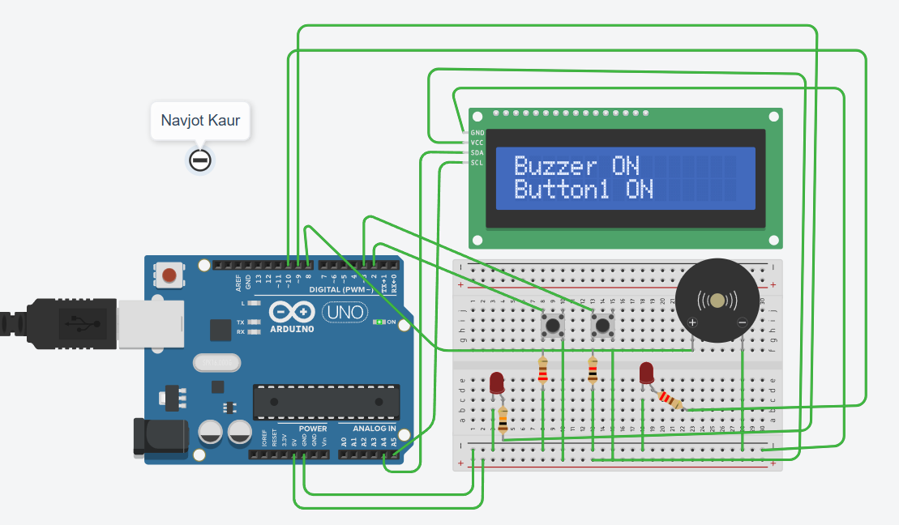
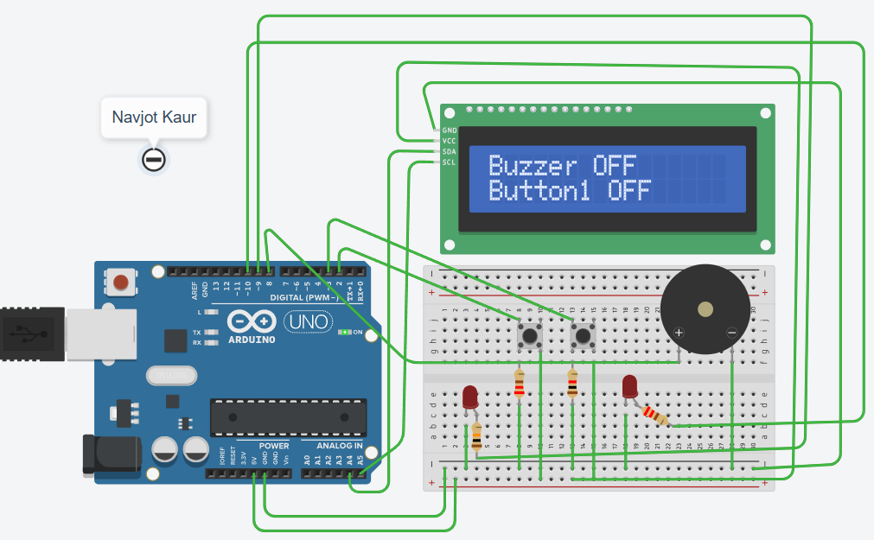

- Case 3: When we press button 2 once then LED will turn ON and print “Button2 ON” in Row 2 and “Lights ON” in Row 1.
- Case 4: When we release button 2 again then LED will turn OFF and print “Button2 OFF” in Row 2 and “Light OFF” in Row 2.
#include <Wire.h>
#include <LiquidCrystal_I2C.h>
LiquidCrystal_I2C lcd(0x27, 16, 2);
int b2 = 3;
int led1 = 9;
int led2 = 10;
int lightState = 0;
void setup() {
pinMode(b2, INPUT);
pinMode(led1, OUTPUT);
pinMode(led2, OUTPUT);
lcd.init();
lcd.backlight();
lcd.print("System Ready");
delay(1000);
lcd.clear();
}
void loop() {
if (digitalRead(b2) == HIGH) {
lightState = !lightState;
if (lightState == 1) {
digitalWrite(led1, HIGH);
digitalWrite(led2, HIGH);
lcd.clear();
lcd.setCursor(0, 0);
lcd.print("Lights ON");
lcd.setCursor(0, 1);
lcd.print("Button2 ON");
}
else {
digitalWrite(led1, LOW);
digitalWrite(led2, LOW);
lcd.clear();
lcd.setCursor(0, 0);
lcd.print("Light OFF");
lcd.setCursor(0, 1);
lcd.print("Button2 OFF");
}
delay(300);
}
}

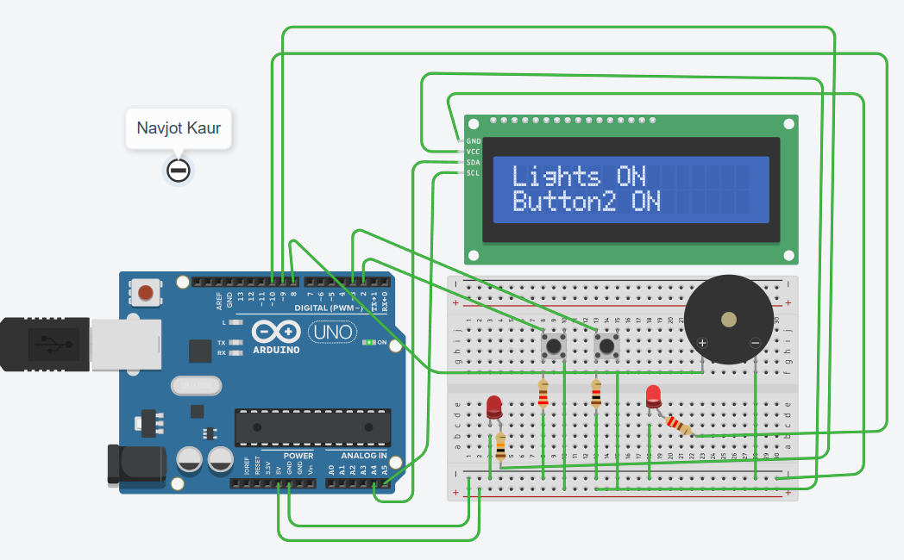

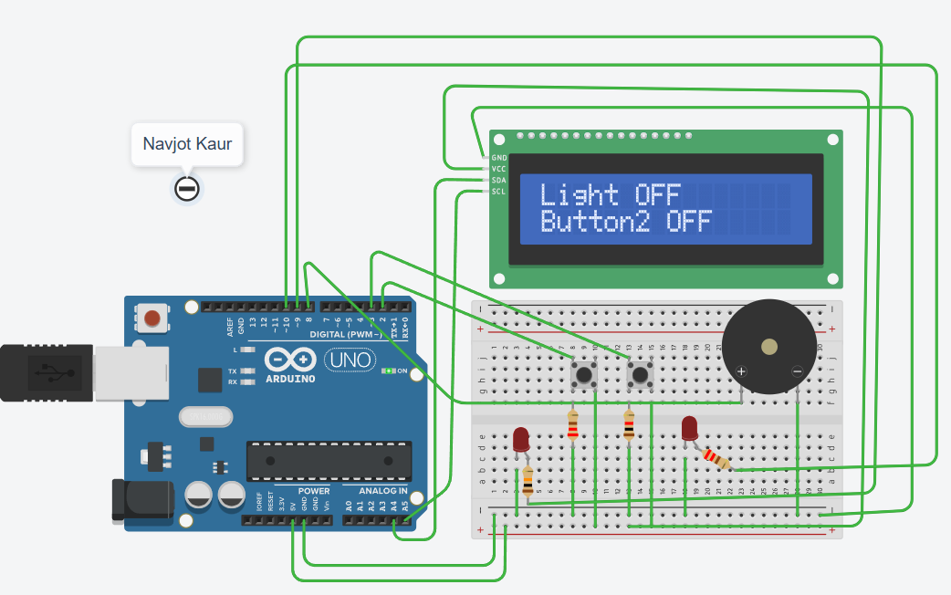

5. Learning outcomes (What I have learnt):
- Learned to interface pushbuttons, LEDs, buzzer, and LCD with Arduino Uno.
- Learned to use pushbuttons as toggle switches.
- Learned to control LEDs and buzzer using Arduino.
- Learned to display ON/OFF status on the LCD.
- Learned basic digital input and output operations.

